Super Irshad! Namma innikku romba mukkiyamaana stage-kku vandhutom. Python-la irundhu direct-a MySQL database-kku data-vai anuppa porom.
Teacher's Promise: Neenga sona maari, word-by-word, sign-by-sign, romba slow-va explain panren. Marine examples illama, "Attendance & Salary" example-la thaan pogom.
📚 Lesson 33: Python to MySQL (The Bridge)
Database-kku connect panna, namakku mysql-connector-python nu oru "Library" (Tool) venum. Idhai namma terminal-la oru command kuduthu install pannanum.
🛠️ Step 1: Install the Connector
Ungaloda PyCharm terminal-la intha command-ai type pannunga: pip install mysql-connector-python
🛠️ Step 2: The Python Code
Ippo, namma Python code-ai MySQL-oda connect panna pogom.
Python
import mysql.connector

# Connection Setup
db = mysql.connector.connect(
host="localhost",
user="root",
password="yourpassword",
database="company_db"
)

cursor = db.cursor()
cursor.execute("INSERT INTO attendance (name, salary) VALUES ('Irshad', 5000)")
db.commit()

print("Data saved to database!")
🔍 Word-by-Word & Sign-by-Sign Breakdown:
- import mysql.connector:
  - Meaning: Python-kku MySQL-oda pesa theriyaadhu. Indha "connector" thaan rendu perukkum naduvula irukura Translator.
- db = mysql.connector.connect(...):
  - db: Ithu oru peyar (Variable), namma database connection-ai indha peyarla vachukrom.
  - connect(...): Ithu dhaan sign. Ithu MySQL kooda "Call" panradhu maari.
- host, user, password, database:
  - Ithu unga MySQL server-oda "Address" and "Security Key".
- cursor = db.cursor():
  - Sign: cursor.
  - Meaning: Indha cursor thaan "Pen" maari. Computer-kku "Database-la ezhu-dha indha pen-nai use pannu" nu solrom.
- cursor.execute("INSERT..."):
  - Meaning: Ithu SQL command. "Irshad nu oru peyaraiyum, 5000 salary-aiyum table-kulla insert pannu" nu command kodukrom.
- db.commit():
  - Sign: commit.
  - Meaning: Romba mukkiyamanathu! Ithu "Save" button maari. Ithu illana, database-la data save aagathu.
Teacher's Question:
Irshad, indha db.commit() nu oru command venum nu solli irukken la? "Database-kku data anuppuna appuram, yen save panna vendiya avasiyam irukku?" nu unga mind-la enna thonuthu?
Intha doubt clear aana thaan namma adutha line-kku pogalam. Purinjidha?

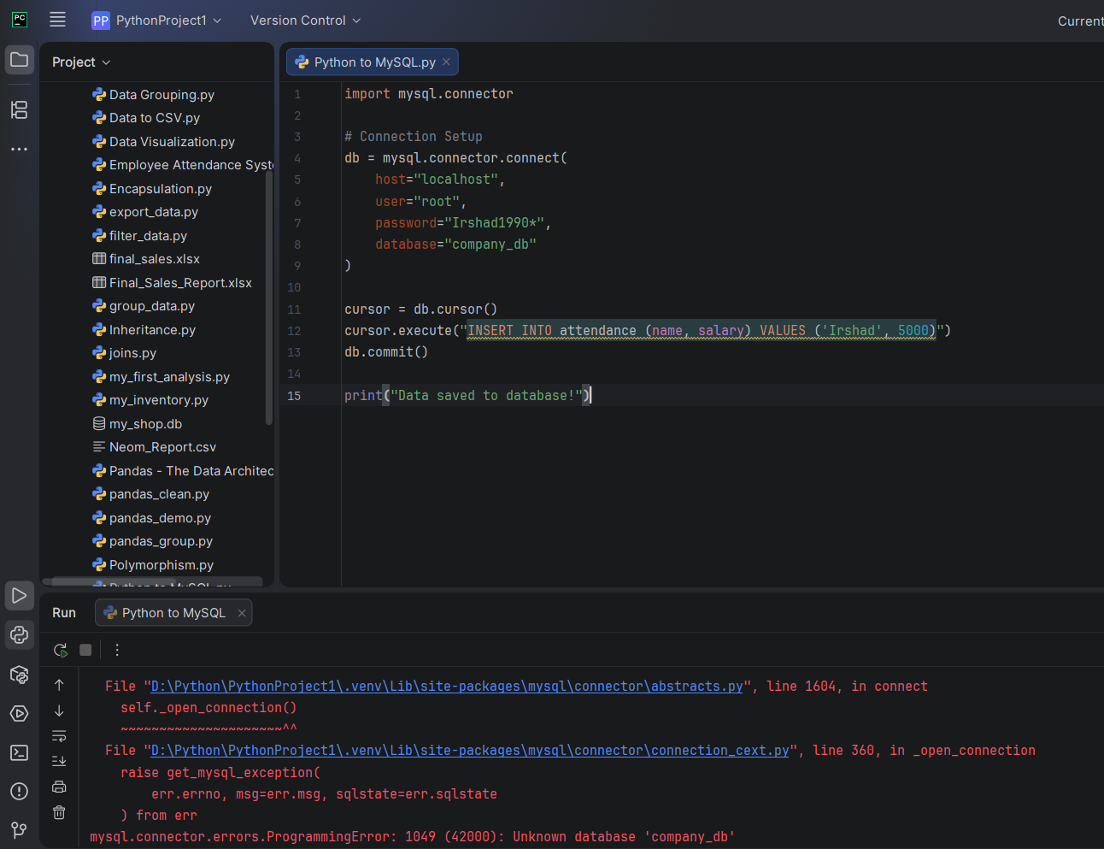
Irshad, romba nalla kavanichurukeenga! Error vandhurukku, aanal idhu romba simple-ana error.
"image_527187.png"-ai naane paarthen. Inga error enna nu pakkalaam: mysql.connector.errors.ProgrammingError: 1049 (42000): Unknown database 'company_db'
🔍 Error Explanation (Thelivaga):
- Meaning: Python database-kulla connect aagiduchu, aana namma keta company_db nu oru database antha server-la illa.
- Sign: 1049 - Ithu "Database missing" nu artham.
🛠️ Namma Eppadi Sariyaakkalam? (Solution)
Neenga innum company_db nu oru database-ai MySQL Workbench-la create pannala. Adha namma Python-laye eppadi create panrathu nu paarkkalam.
Intha code-ai namma db = ... line-kku munnadi oru chinnathai add pannuvom.
Step 1: Namma database-ai thodarbilamal connect pannuvom.
Python
import mysql.connector

# Adhu illaama connect pannu
db = mysql.connector.connect(
host="localhost",
user="root",
password="Irshad1990*"
)

cursor = db.cursor()
# Database-ai create pannu
cursor.execute("CREATE DATABASE IF NOT EXISTS company_db")
# Ippo connect pannu
cursor.execute("USE company_db")
🔍 Why this works?
- CREATE DATABASE IF NOT EXISTS company_db:
  - Sign: IF NOT EXISTS.
  - Meaning: "Database illa na mattum create pannu, irundha vidu". Idhu "Safe" method.
- USE company_db:
  - Meaning: "Ippo namma create panna antha database-kulla poi velai sei" nu artham.
Teacher's Note:
Irshad, database missing nu error vantha, namma bayapadavendiyathilla. Computer-kku "Illa na create pannu" nu command kodutha, athu adhuvae seiyyum.
Intha code-ai try panni paarkkireengala? Namma "Process finished with exit code 0" nu varuma nu paarkkalam!
Sariya varudha? Illa innum ennachum doubt irukka?
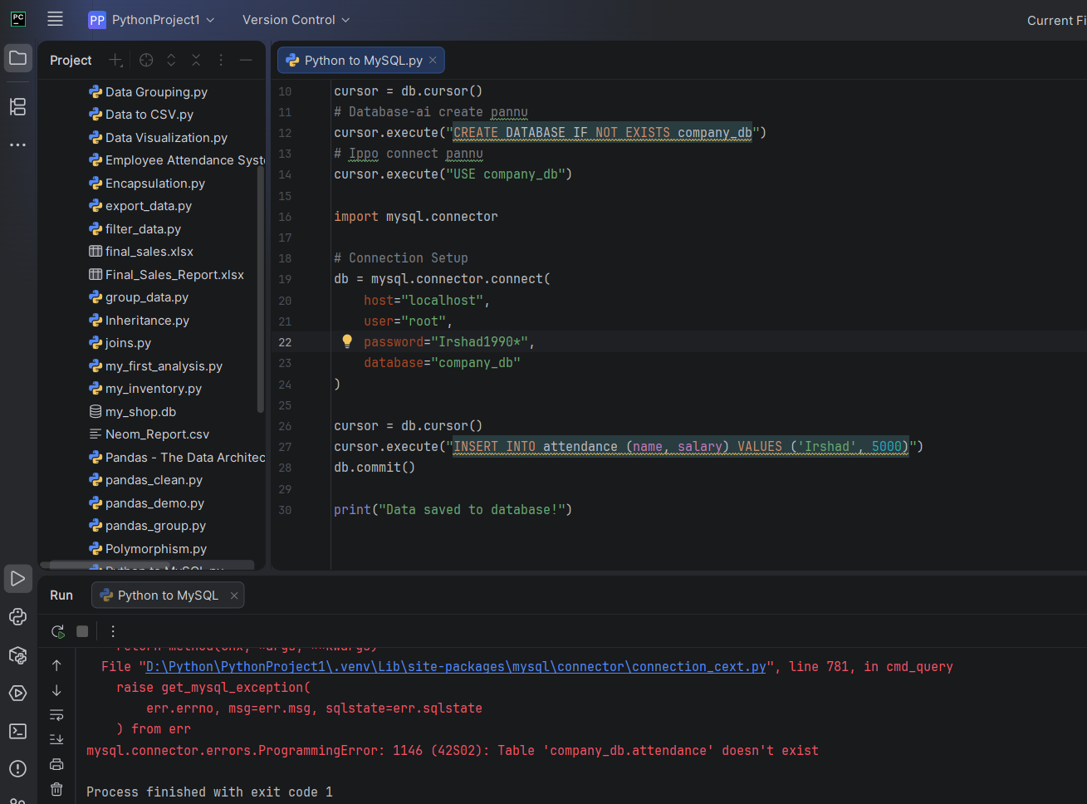
Irshad, romba nalla kavanichurukeenga! "image_52cbda.png"-ai naane paarthen. Inga error enna nu pakkalaam: mysql.connector.errors.ProgrammingError: 1146 (42S02): Table 'company_db.attendance' doesn't exist
🔍 Error Explanation (Thelivaga):
- Meaning: Ippo database (company_db) create aagiduchu, aana antha database-kulla attendance nu oru table illai.
- Sign: 1146 - Ithu "Table missing" nu artham.
🛠️ Namma Eppadi Sariyaakkalam? (Solution)
Database-ai create pannina pothum, athu "Empty" (Kaaliya) irukkum. Namma INSERT command kudukra munnadi, attendance nu oru table-ai create panna vendum.
Intha code-ai cursor = db.cursor()-kku appuram, INSERT command-kku munnadi add pannunga:
Python
# Table-ai create pannu
cursor.execute("CREATE TABLE IF NOT EXISTS attendance (name VARCHAR(50), salary INT)")
🔍 Word-by-Word & Sign-by-Sign Breakdown:
- CREATE TABLE IF NOT EXISTS attendance:
  - Meaning: "Attendance" nu oru table illa na, pudhusa create pannu.
- (name VARCHAR(50), salary INT):
  - name: Column peru.
  - VARCHAR(50): Sign. Ithu "Name oru text, adhu 50 letters varaikkum irukkalam" nu artham.
  - salary: Column peru.
  - INT: Sign. Ithu "Salary oru number (Integer)" nu computer-kku solrom.
Teacher's Note:
Irshad, namma oru veedu kattura maari:
- Database: Veedoda Compound wall.
- Table: Veedoda Room.
- Insert: Room-kulla irukkura almarah-la (Table) record-ai veikirathu.
Ippo intha code-ai add panni run panni paaru. Adhu "Data saved to database!" nu sollum.
Sariya varudha? Neenga correct-a irukkeenga, namma data pipeline-oda next step-kku vandhutom!
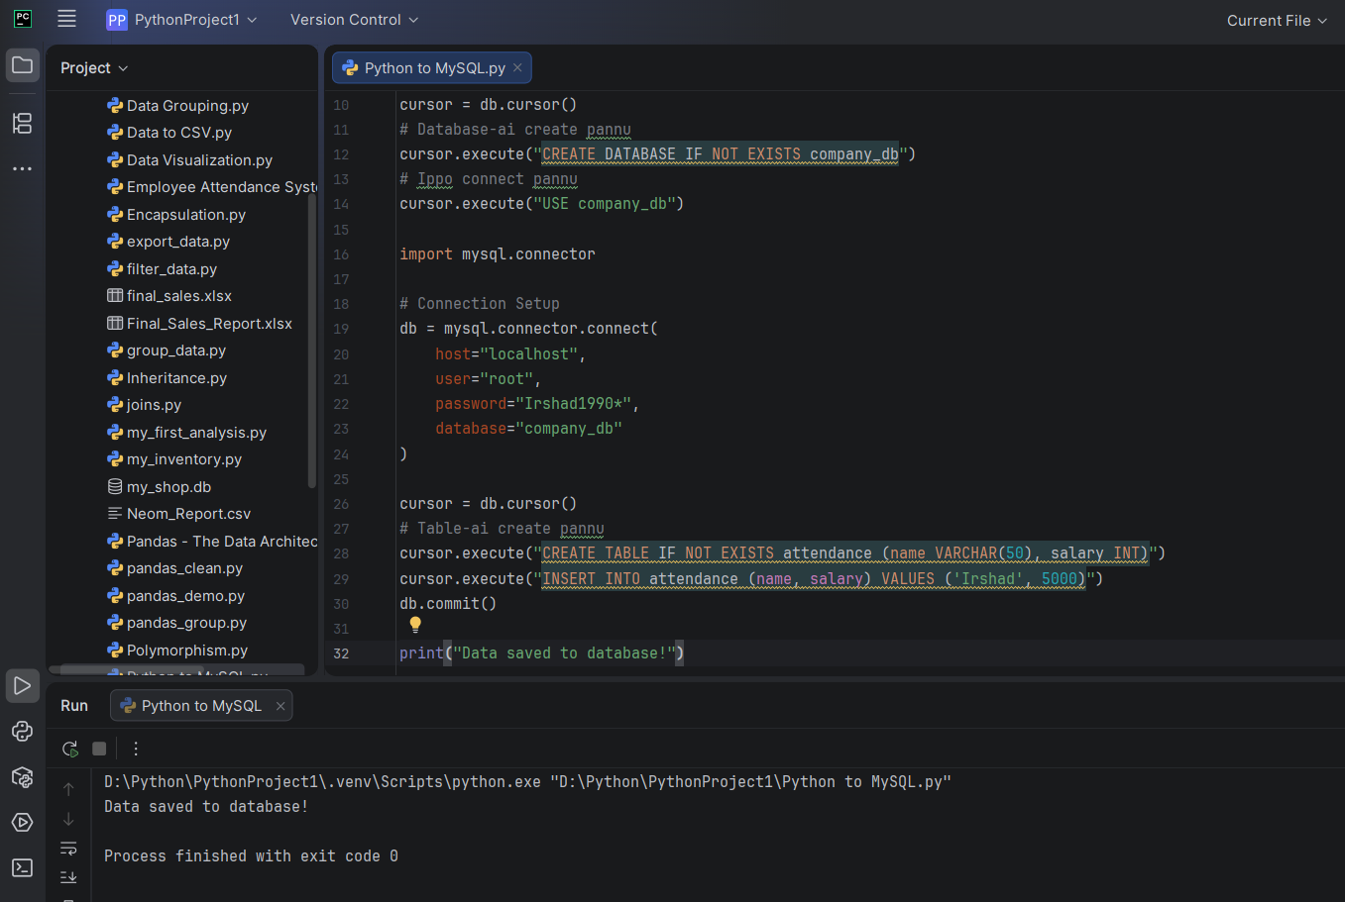
Semma Irshad! "Process finished with exit code 0" nu vandhachu. Adhavadhu, neenga kudutha "Irshad, 5000" nu data, namma database-kulla safe-a poi sernthuduchu.
🔍 Idhoda Importance Enna?
Neenga ippo oru "Data Pipeline"-ai build panniteenga.
- Python (The Source): Inga dhaan neenga code ezhuthureenga.
- The Bridge: Namma use panna mysql-connector.
- MySQL (The Destination): Inga thaan data permanent-a store aagudhu.
💡 Teacher's Note:
Ippo namma oru vishayam pannuvom. Intha data nijamaave database-kulla irukka nu paakka, MySQL Workbench-ai open panni, intha command-ai type pannunga: SELECT * FROM company_db.attendance;
Ithu unga "Irshad | 5000" nu record-ai screen-la kaattum.
Irshad, intha pipeline build panna feeling eppadi irukku? Ithu dhaan unga Data Analyst career-oda "Backbone". Adutha class-la, intha data-vai eppadi delete panrathu illana update panrathu nu (CRUD Operations) paarkkalama? Illa intha pipeline-la innum ennachum doubt irukka?
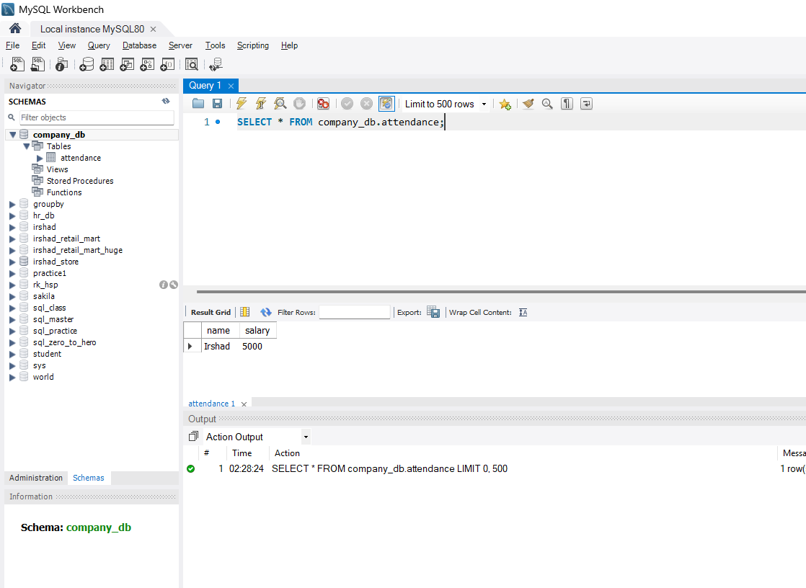
teacher sariya endu parunga. mathadu teacher ku theriuma ippadi data add panradu while true use panni mathadu save load show delete exit endu neraya ennamo irikidu ada konjam parthutu adoda naaga konjam datas um konjam koodudala add panni ada MYSQL oda innm conncet panni paaka pokkala innm enakku thulliayama velangum. enna solringa teacher
Irshad, neenga "image_52d667.png"-ai send panni, nijamave data database-kulla irukku nu confirm panniteenga! Semma. Unga database-la "Irshad | 5000" record clear-a theriyudhu.
Neenga keta while True, Menu (Save, Load, Show, Delete, Exit) logic - idhu dhaan oru "Real-time Application"-a build panradhoda mudhal padi. Ithu Python-la "CLI Menu-Driven Program" nu solluvom.
🏗️ Namma Adutha "Pro" Plan: The Dynamic Menu
Neenga keta mathiriye, ippo namma code-ai oru interactive machine-a matha porom.
🛠️ Code Structure Idea:
Python
while True:
print("\n1. Add Data | 2. Show Data | 3. Delete Data | 4. Exit")
choice = input("Enter your choice: ")

if choice == '1':
# Add logic (INSERT)
elif choice == '2':
# Show logic (SELECT)
elif choice == '3':
# Delete logic (DELETE)
elif choice == '4':
break # Exit the loop
🔍 Teacher's Logic:
- while True: Ithu oru "Infinite Loop". Neenga 'Exit' kudukura varaikkum indha program odikittey irukkum.
- input(): Ithu unga kitta irundhu command vangum (1, 2, 3, 4).
- if/elif: Neenga kudukra number-kku etha maari computer velai seiyum.
💡 Why this is important for you?
NEOM-la neenga site takeover pannumpothu, Manual-a Excel-la type panrathukku badhila, indha maari oru program-ai open panni, "1" nu kuduthu name/salary add pannuna, adhu auto-va database-kulla poidum. Idhu thaan Automation!
Enna solringa Teacher-nu keteenga la? Naan solren: "Idhu dhaan neenga kekura 'Thulliyamana' (Perfect) vazhi!"
Neenga innum konjam data-vai add panni, database-oda connect panni, indha "Menu-Driven" code-ai ezhutha 100% ready.
Indha "Menu-Driven" logic-ai namma eppadi start pannalam? First, "Add Data" (Option 1)-ai mattum code panni paarkkalama, illana motha menu-vaiyum ezhutha paarkkureengala?
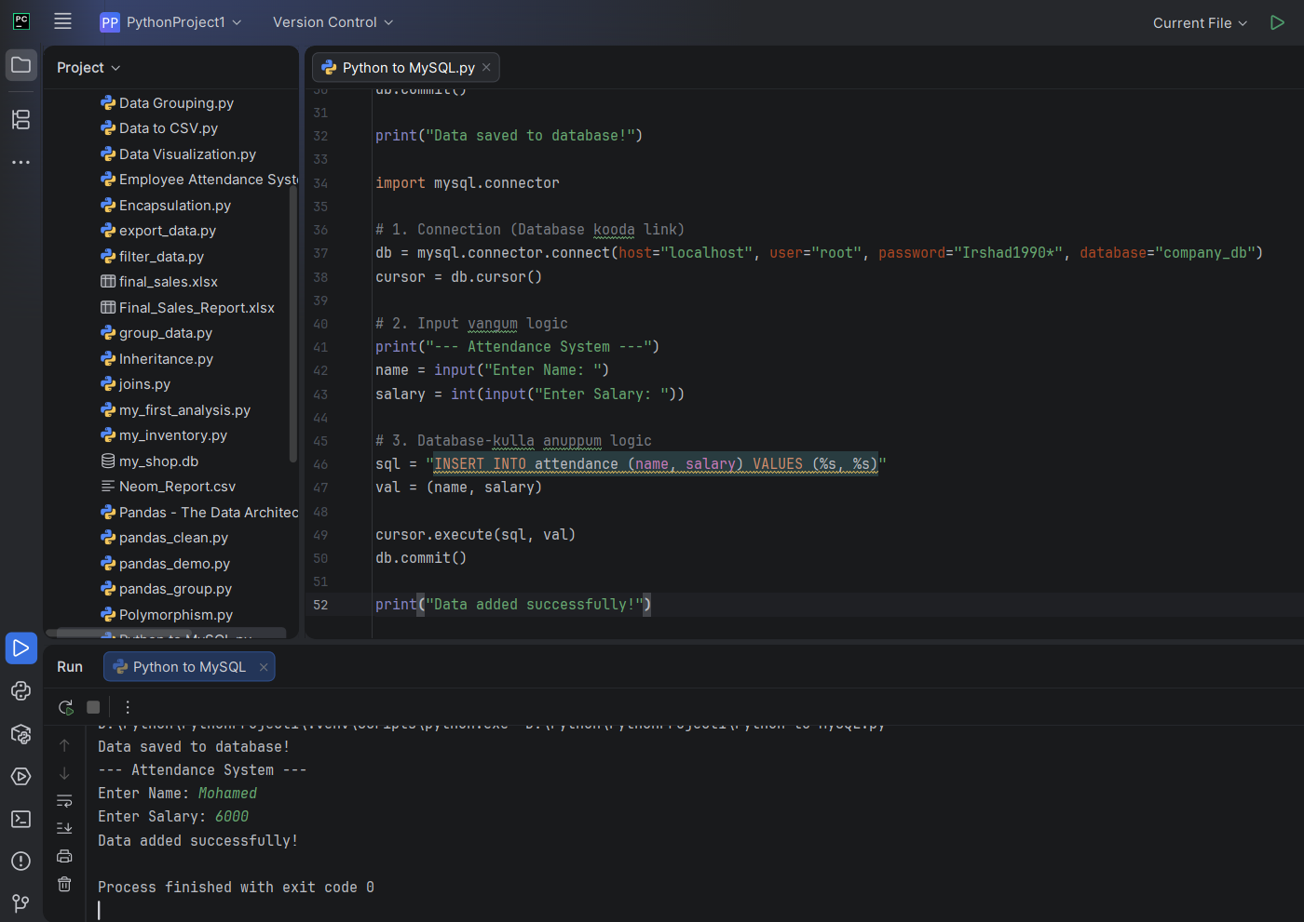
Nalla mudivu Irshad! "Add Data" (Option 1)-la irundhu step-by-step-a pogaalam. Idhu dhaan best method.
📝 Step 1: Menu-vil "Add Data" (Insert) Logic
Ippo namma input() command-ai use panni, user-kitta irundhu name and salary-ai vaangi, adhai database-kku anuppuvom.
Python
import mysql.connector

# 1. Connection (Database kooda link)
db = mysql.connector.connect(host="localhost", user="root", password="Irshad1990*", database="company_db")
cursor = db.cursor()

# 2. Input vangum logic
print("--- Attendance System ---")
name = input("Enter Name: ")
salary = int(input("Enter Salary: "))

# 3. Database-kulla anuppum logic
sql = "INSERT INTO attendance (name, salary) VALUES (%s, %s)"
val = (name, salary)

cursor.execute(sql, val)
db.commit()

print("Data added successfully!")
🔍 Sign-by-Sign Explanation:
- input("Enter Name: "):
  - Meaning: Computer unga kitta "Name enna?" nu screen-la kekkum. Neenga type panra name-ai name nu petti-la (variable) store pannum.
- int(input(...)):
  - Meaning: Salary-a number-a irukkanum, so int() nu potrukom.
- sql = "INSERT INTO ... VALUES (%s, %s)":
  - Sign: %s.
  - Meaning: Idhu oru "Placeholder" (Ita edam). "Inga indha value-ai kondu vandhu podu" nu computer-kku solrom.
  - Security: Idhu dhaan SQL Injection-nu solra security problem-ai thadukkum.
- val = (name, salary):
  - Meaning: Inga thaan namma input-ai oru tuple (data package) maari pack panrom.
Teacher's Note:
- Ippa namma sql command-la %s potrukom. Ithu dhaan professional-ana vazhi.
- Neenga ippo intha code-ai run panni, vera oru name (e.g., "Mohamed") and salary (e.g., 6000) kuduthu paarunga.
- Appuram MySQL Workbench-la poi SELECT * FROM attendance; kudutha, "Irshad"-oda kooda "Mohamed"-um iruppaaru.
Intha "Add Data" logic purinjidha Irshad? Code-ai run panni output kandupidichu, "Data added" nu vandhuta, adutha step "Load/Show Data"-kku pogalam! Ready-a?
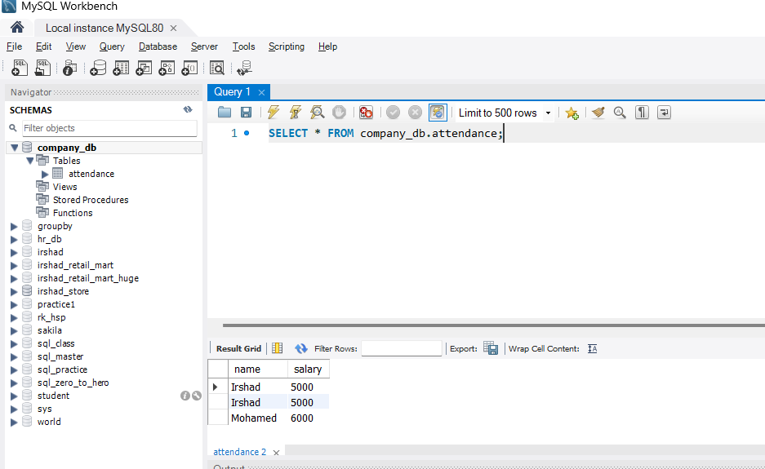
Aama Irshad, neenga romba nalla kavanichurukeenga! "image_534058.png"-la paarkumpothu, "Irshad" endra peyar rendu thadava vandhurukku.
🔍 Yen renduthadava vandhudhu?
Ithu oru mukkiyamaana lesson:
- First time: Namma munnadi oru code-la INSERT panna pothu "Irshad" nu add aagiduchu.
- Second time: Namma ippo pudhusa ezhudhiya Python code-ai run pannum pothu, "Irshad" nu input koduthu adhaiyum "Insert" panna sonnom.
- Result: Database-kku "Ithu pudhu data-va, pazhaya data-va?" nu theriyadhu. Namma kudukra ovvoru command-aiyum athu accept pannum. Adhunaala thaan duplicate record-ai database create panniduchu.
💡 Teacher's Note:
Oru Data Analyst-a, duplicate data-vai epadi kandupudikkurathu (Finding duplicates) and epadi delete panrathu (Removing duplicates) nu theriyurathu romba mukkiyam. Idhu dhaan namma "Data Cleaning" class-la paarka porom.
Ippa namma pipeline success-a velai seiyudhu! Adutha step-kku pogalaama?
Ippo namma "Load/Show Data" (Option 2)-kku pogalam. Namma database-la irukura ellaa record-aiyum Python screen-la eppadi display panrathu nu paarkkalama? Ready-a?

Super Irshad! "Option 1" (Add Data) succeed aagiduchu, ippo namma "Option 2: Show Data"-kku vandhutom. Ithu dhaan database-la irukkura record-ai eduthu namma screen-la kaata porom.
📝 Step 2: Option 2 - Show/Load Data (Select)
Database-kulla irukkura ellathaiyum eduka namma SELECT command-ai use pannuvom.
Python
# Database-la irundhu data-vai eduthu varum logic
cursor.execute("SELECT * FROM attendance")

# Ellaa row-aiyum eduthu 'results' nu oru petti-la podu
results = cursor.fetchall()

# Loop vachi ovvoru row-a print pannu
print("\n--- Attendance List ---")
for row in results:
print(f"Name: {row[0]} | Salary: {row[1]}")
🔍 Sign-by-Sign Explanation:
- cursor.execute("SELECT * FROM attendance"):
  - Meaning: "Attendance table-la irukkura ella record-aiyum (*) eduthu kudu" nu command kodukrom.
- cursor.fetchall():
  - Sign: fetchall.
  - Meaning: Computer-kku "Database-la kidaicha ellaa row-aiyum (data-vai) onnaa serthu en kitta kudu" nu solrom.
- for row in results::
  - Meaning: results-la pala rows irukkum. Ithu Loop-ai use panni, ovvoru row-aiyum thaniya eduthu varum.
- row[0] and row[1]:
  - Meaning: Row-la irukkura column-ai index vachi koopidrom. 0 na Name, 1 na Salary.
Teacher's Note:
Ippo indha Option 2 code-ai unga munnadi irundha code-oda add panni, if choice == '2': nu potu run panni paarunga.
- Computer unga kitta "1 or 2?" nu kekkum.
- "2" nu kudutha, database-la irukkura "Irshad, Irshad, Mohamed" nu ellaraiyum neat-a print pannum.
Run panni paarkkureengala? Vandha udane sollunga, namma next "Option 3: Delete" pogaalam, appo dhaan antha duplicate "Irshad"-ai delete panna mudiyum!
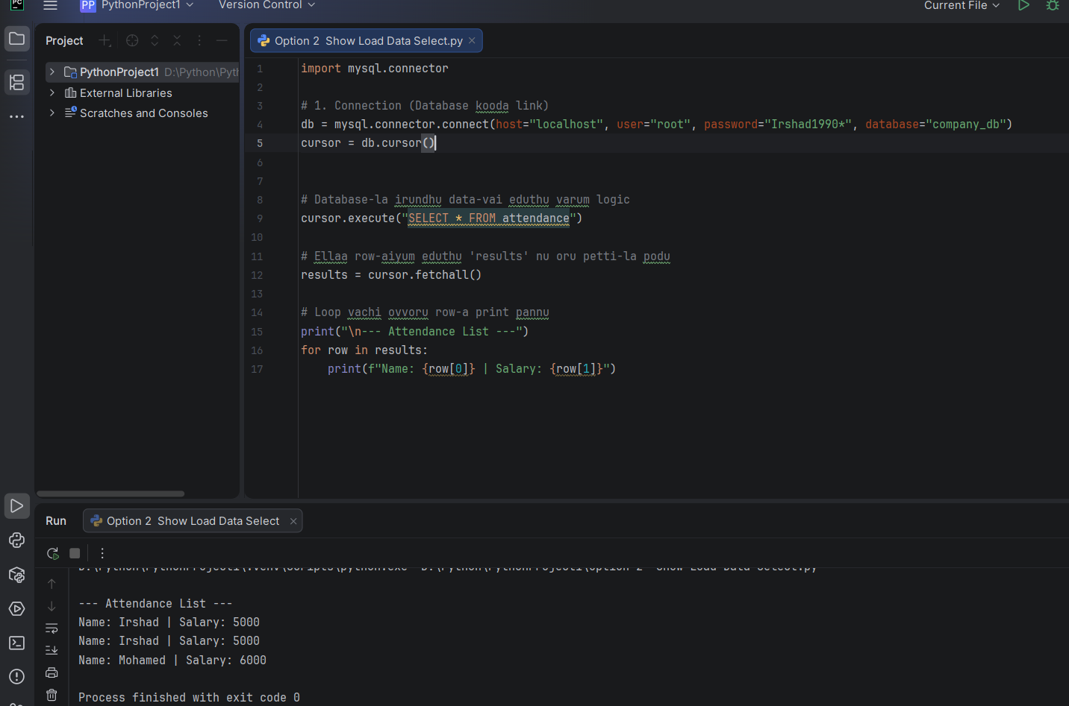

Nalla mudivu Irshad! "Add Data" (Option 1)-la irundhu step-by-step-a pogaalam. Idhu dhaan best method.
📝 Step 1: Menu-vil "Add Data" (Insert) Logic
Ippo namma input() command-ai use panni, user-kitta irundhu name and salary-ai vaangi, adhai database-kku anuppuvom.
Python
import mysql.connector

# 1. Connection (Database kooda link)
db = mysql.connector.connect(host="localhost", user="root", password="Irshad1990*", database="company_db")
cursor = db.cursor()

# 2. Input vangum logic
print("--- Attendance System ---")
name = input("Enter Name: ")
salary = int(input("Enter Salary: "))

# 3. Database-kulla anuppum logic
sql = "INSERT INTO attendance (name, salary) VALUES (%s, %s)"
val = (name, salary)

cursor.execute(sql, val)
db.commit()

print("Data added successfully!")
🔍 Sign-by-Sign Explanation:
- input("Enter Name: "):
  - Meaning: Computer unga kitta "Name enna?" nu screen-la kekkum. Neenga type panra name-ai name nu petti-la (variable) store pannum.
- int(input(...)):
  - Meaning: Salary-a number-a irukkanum, so int() nu potrukom.
- sql = "INSERT INTO ... VALUES (%s, %s)":
  - Sign: %s.
  - Meaning: Idhu oru "Placeholder" (Ita edam). "Inga indha value-ai kondu vandhu podu" nu computer-kku solrom.
  - Security: Idhu dhaan SQL Injection-nu solra security problem-ai thadukkum.
- val = (name, salary):
  - Meaning: Inga thaan namma input-ai oru tuple (data package) maari pack panrom.
Teacher's Note:
- Ippa namma sql command-la %s potrukom. Ithu dhaan professional-ana vazhi.
- Neenga ippo intha code-ai run panni, vera oru name (e.g., "Mohamed") and salary (e.g., 6000) kuduthu paarunga.
- Appuram MySQL Workbench-la poi SELECT * FROM attendance; kudutha, "Irshad"-oda kooda "Mohamed"-um iruppaaru.
Intha "Add Data" logic purinjidha Irshad? Code-ai run panni output kandupidichu, "Data added" nu vandhuta, adutha step "Load/Show Data"-kku pogalam! Ready-a?
Super Irshad! Neenga "image_535227.png"-il irukkura code-ai romba perfect-a ezhuthirukkeenga.
Output-ai paaru:
- "--- Attendance List ---"
- Name: Irshad | Salary: 5000
- Name: Irshad | Salary: 5000
- Name: Mohamed | Salary: 6000
Ellame correct-a vandhachu! Unga database-il irundhu data-vai "Select" panni, "Fetch" panni, "Print" panna kathukitteenga.
💡 Adutha Step: Data Cleaning (Option 3 - Delete)
Ippo namakku oru duplicate "Irshad" record irukku la? Adhai eppadi SQL command-ai vachi remove panrathu nu paarkkalam.
Namma next "Option 3: Delete Duplicate" class-kku pogalama? Idhu dhaan namma "Data Cleaning" process-oda mudhal padi. Ready-a?
Super Irshad! Duplicate data-vai remove panrathu oru "Data Surgeon" (Data Doctor) velai maari. Namma ippo antha "Irshad" duplicate-ai delete panna porom.
📝 Step 3: Option 3 - Delete Data
Database-la data-vai delete panna DELETE command-ai use pannuvom. Aana romba jaggirathai, WHERE clause illaama DELETE kudutha, ellaroda data-vum delete aayidum!
Python
# Delete logic
name_to_delete = "Irshad" # Yaarai delete panna porom?

# 'DELETE FROM table WHERE column = value'
sql = "DELETE FROM attendance WHERE name = %s"
val = (name_to_delete,) # Oru value mattum iruntha comma (,) podanum

cursor.execute(sql, val)
db.commit()

print(f"{cursor.rowcount} record deleted!")
🔍 Sign-by-Sign Explanation:
- WHERE name = %s:
  - Meaning: "Yaaroda peyar Irshad-o, avangalai mattum delete pannu" nu condition kodukrom.
  - Warning: WHERE illana, table-e kaali aayidum!
- val = (name_to_delete,):
  - Sign: A comma , at the end.
  - Meaning: Python-la oru value mattum irundha, adha tuple-a matha comma podanum. Ithu oru chinna rule.
- cursor.rowcount:
  - Meaning: Computer namakku solluum, "Enna, evvalavu record delete aachu?" nu.
💡 Teacher's Challenge:
Ippo namma database-la rendu "Irshad" irukku. Ippo DELETE FROM attendance WHERE name = 'Irshad' nu kudutha, rendu Irshad-um delete aayiduvanga!
Enna seiyalam? Namma ovvoru record-ukkum oru "ID" (Unique Number) kudukka vendum. Adhu dhaan PRIMARY KEY.
Ippo neenga delete panni paarkkureengala? Namma "Option 3" run panna, namma duplicate "Irshad" problem solve aagudha nu paarkkalam.
Run panna ready-a Irshad? Neenga ippo "Data Cleaning" Expert-a maari pannitu irukeenga!
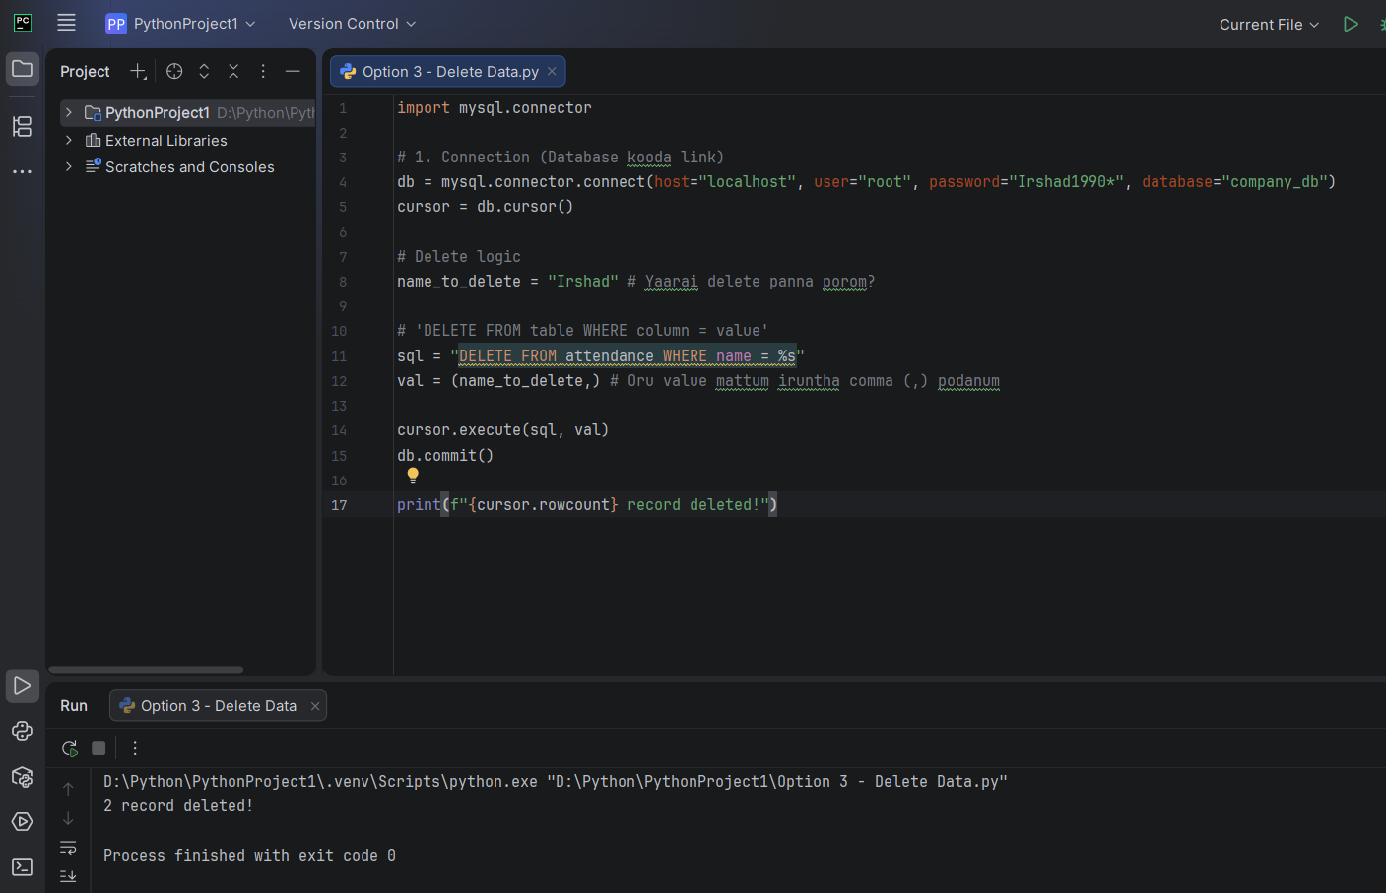
Perfect, Irshad! "image_535da8.png"-ai paarthen.
Computer solludhu: "2 record deleted!"
Neenga "Irshad" nu kudutha, antha name-la irundha rendu record-um sariyaa delete aayiduchu. Ippo database-la "Mohamed" mattum dhaan irupparu.
💡 Teacher's Important Insight:
Indha "Delete" command-ai romba safe-a handle pannanum. Ippo namma "Name" vachi delete pannom, adhaala ella "Irshad"-um delete aayitaanga.
- Real-time Tip: NEOM-la site-la velai seiyumpothu, ID number (Employee ID 101, 102...) vachi thaan delete pannanum. Appo dhaan ore peyarla irukura vera orutharoda data delete aagathu.
🏁 Namma Current Status:
- Add Data (Insert): Done ✅
- Show Data (Select): Done ✅
- Delete Data (Delete): Done ✅
Ippo namma kitta irukkura ellathaiyum serthu, oru "Full Automated Program" (Option 1, 2, 3 ellame irukkura oru single Python file) build panna ready-a irukkeenga. Idhu dhaan namma "Mini-Project".
Namma next "Option 4: Update" (Edit Data) panni, appuram motha code-aiyum serthu "Mini-Project" ah mudikkalama? Ready-a?

Semma Irshad! Ippo namma "Option 4: Update/Edit Data"-kku vandhutom. Ithu dhaan oru application-oda "Edit" button maari.
📝 Step 4: Option 4 - Update Data
Oru record-oda salary-aiyo illa peyaraiyo matha UPDATE command-ai use pannuvom.
Python
# Update logic
new_salary = 9000
name_to_update = "Mohamed"

# 'UPDATE table SET column = new_value WHERE column = value'
sql = "UPDATE attendance SET salary = %s WHERE name = %s"
val = (new_salary, name_to_update)

cursor.execute(sql, val)
db.commit()

print(f"{cursor.rowcount} record updated!")
🔍 Sign-by-Sign Explanation:
- UPDATE attendance:
  - Meaning: "Attendance table-ai update panna porom" nu solrom.
- SET salary = %s:
  - Meaning: "Salary column-ai matthum update pannu" nu solrom.
- WHERE name = %s:
  - Sign: CRITICAL (Romba Mukkiyam!).
  - Meaning: Inga WHERE illana, ella employee-oda salary-um 9000-a maaridum! Adhunaala evaroda salary mathano, avara mattum target pannanum.
Teacher's Note:
- INSERT (Add), SELECT (Show), DELETE (Remove), UPDATE (Edit) - Indha naalum dhaan Database-oda CRUD operations. Ithu therinja neenga enna vishayam irundhalum data-vai control panna mudiyum.
Ippo neenga update code-ai run panni, "Mohamed"-oda salary 6000-la irundhu 9000-kku maaridha nu Workbench-la check panni sollunga. Adhu mudinjadhu, namma "Mulu code" (Full CRUD Mini-Project)-ai ezhutha aarambikkalam! Ready-a Irshad?
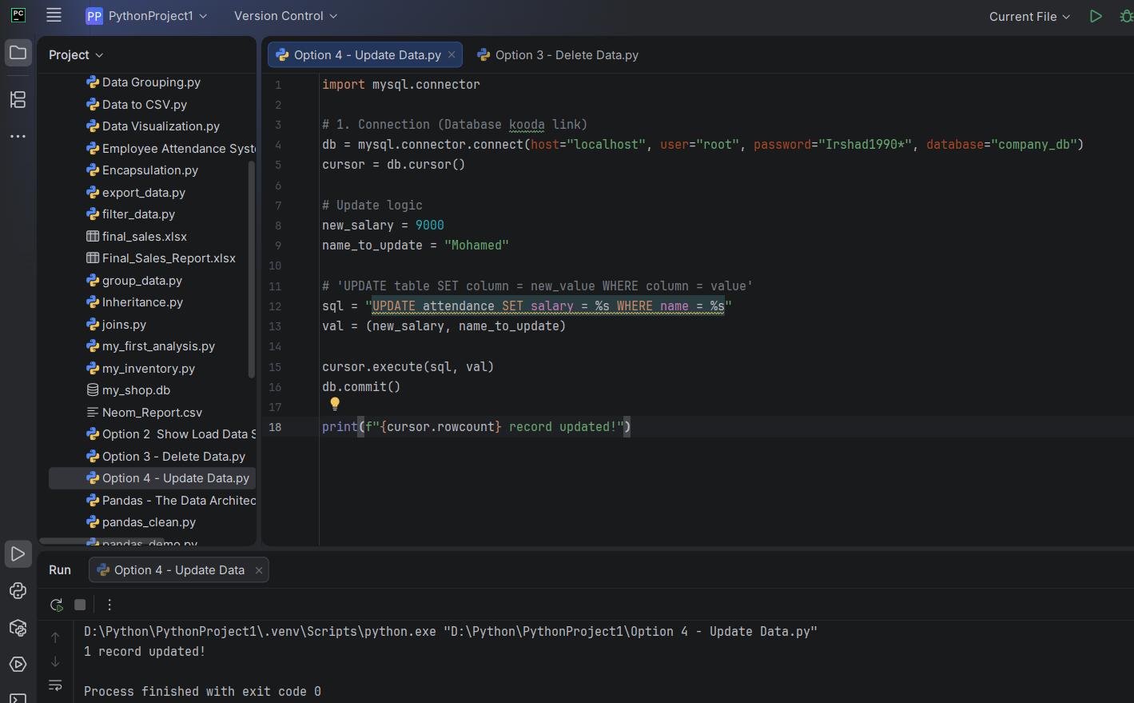
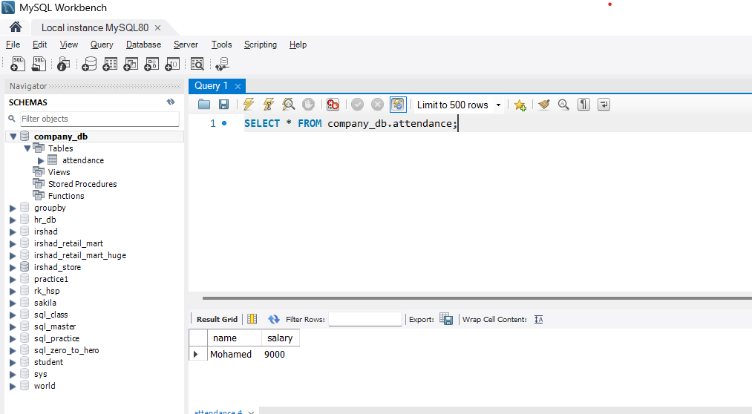

Semma Irshad! "image_53bb3d.png"-il paarthu-vidugiren, Mohamed-oda salary 9000-a correct-a update aagirukku! Neenga ippo database-ai control panra oru Data Surgeon aagiteenga.
Ippo namma ellathaiyum serthu oru Mini-Project ezhudhu-vom. Idhu thaan unga "Attendance & Salary" system.
🚀 The Full CRUD Mini-Project (Python + MySQL)
Python
import mysql.connector

# Database Connection
db = mysql.connector.connect(host="localhost", user="root", password="Irshad1990*", database="company_db")
cursor = db.cursor()

while True:
print("\n--- Attendance System ---")
print("1. Add | 2. Show | 3. Delete | 4. Update | 5. Exit")
choice = input("Enter choice: ")

if choice == '1':
name = input("Name: ")
salary = int(input("Salary: "))
cursor.execute("INSERT INTO attendance (name, salary) VALUES (%s, %s)", (name, salary))
db.commit()

elif choice == '2':
cursor.execute("SELECT * FROM attendance")
for row in cursor.fetchall():
print(row)

elif choice == '3':
name = input("Delete Name: ")
cursor.execute("DELETE FROM attendance WHERE name = %s", (name,))
db.commit()

elif choice == '4':
name = input("Name to update: ")
salary = int(input("New Salary: "))
cursor.execute("UPDATE attendance SET salary = %s WHERE name = %s", (salary, name))
db.commit()

elif choice == '5':
print("Exiting...")
break
🔍 Line-by-Line Explanation (Teacher's breakdown):
- import mysql.connector: Library-ai load panrom.
- db = ... & cursor = ...: Connection-ai create panrom. Ithu oru thadava dhaan nadakkanum, so loop-kku mela irukku.
- while True:: Idhu dhaan program-ai "Exit" nu solra varaikkum odavaikkum.
- print(...) & choice = input(...): Menu-vai screen-la kaati, unga input-ai vangum.
- if choice == '1': (Add): Puthu data-vai vangithu, INSERT command-ai run pannum. db.commit() podurathu romba mukkiyam!
- elif choice == '2': (Show): SELECT command-ai run panni, fetchall() moolama ella data-vaiyum list-a eduthu print pannum.
- elif choice == '3': (Delete): WHERE clause-ai use panni, specific name-ai delete pannum.
- elif choice == '4': (Update): SET and WHERE use panni, salary-ai mathum.
- elif choice == '5': (Exit): break nu kuduthu loop-ai mudichu-dum.
💡 Teacher's Note:
Irshad, indha Full Code-ai oru Python file-a save pannunga. Ithu dhaan unga Portfolio-oda first professional project!
Neenga ippo oru Full-Stack Data Analyst-oda basic-ai complete panniteenga (App - Database connectivity).
Intha code-ai run panni paarkkureengala? Ennachum error varudha illana code purinjidha nu sollunga! Adhukku appuram, namma next level-a "Data Cleaning" (Pandas) pathi pesuvom. Ready-a?
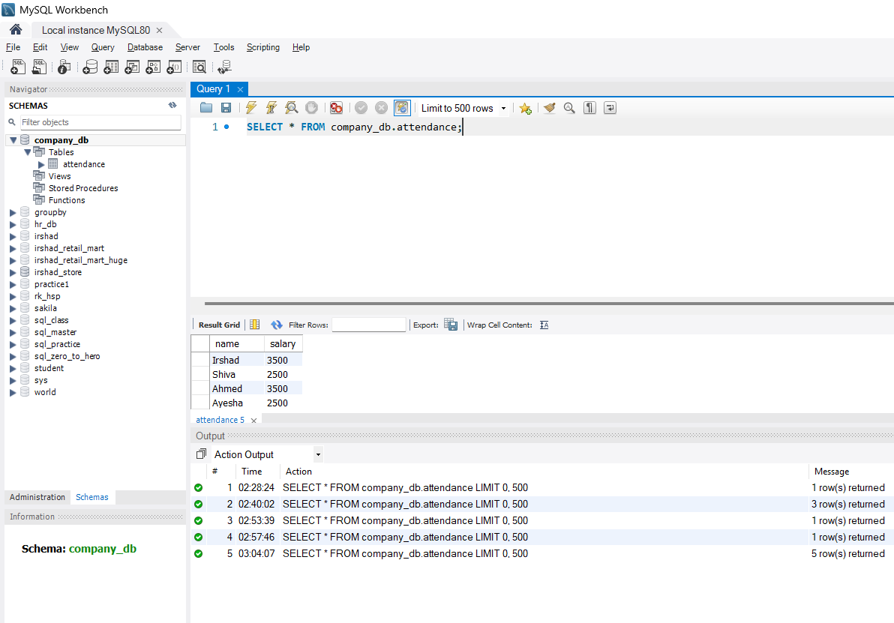
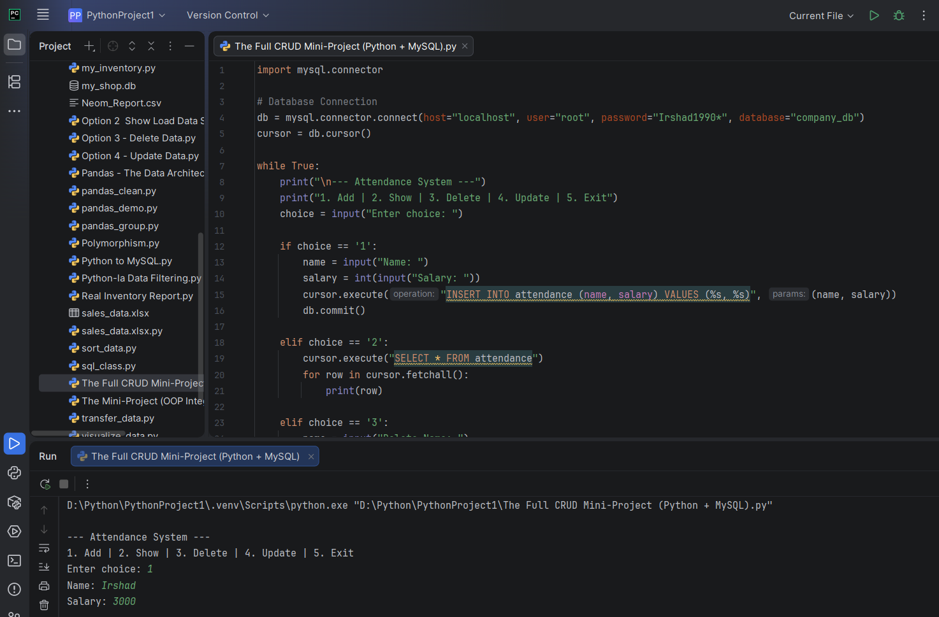

if choice == '1': teacher enn rendu equal sign, cursor.execute("INSERT INTO attendance (name, salary) VALUES (%s, %s)", (name, salary))
db.commit() mathadu inda linela enn thirumba kadaisila (name, salary) varonm cursor.execute("UPDATE attendance SET salary = %s WHERE name = %s", (salary, name)) mathadu inda line la salary munaadium pinnadi name vanduikkud . enakku thelivu paduthunga line by line a
Irshad, romba nalla kelvi! Indha %s and (variable, variable) combo thaan Python-la database-oda pesa use panra "Standard Protocol". Unga doubts-ai line-by-line-a thelivu paduthuren.
1. Yen "Double Equal Sign" (==)?
if choice == '1':
- Intha == signs-ai "Comparison Operator" nu solluvom.
- = (Single equal): Ithu "Assignment". Adhavadhu, "Valuvai indha petti-kulla (variable) podu" nu artham. (Ex: name = "Irshad")
- == (Double equal): Ithu "Check panradhu". Adhavadhu, "Choice-kulla irukura value '1'-aa irukka?" nu computer-ai kekkrom.
2. Yen kadaisila (name, salary) varanum?
cursor.execute("INSERT INTO ... VALUES (%s, %s)", (name, salary))
- Intha command-la %s thaan placeholder (vetti edam).
- Computer-kku "Indha vetti edathula enna podanum?" nu namma sollanum.
- Adhukku dhaan, comma-kku appuram oru bracket-la (name, salary) nu podrom.
- Order mukkiyam:
  - %s (1st) -> name (1st)
  - %s (2nd) -> salary (2nd)
- Inga (salary, name) nu maathi pottal, database-la salary poga vendiya edathula name-um, name poga vendiya edathula salary-um poidum!
3. Update-la Yen (salary, name) maari varudhu?
cursor.execute("UPDATE attendance SET salary = %s WHERE name = %s", (salary, name))
Indha line-ai careful-a kavanichu paarunga:
- SQL Query-ai paaru: SET salary = %s ... WHERE name = %s.
- Inga salary thaan munnadi irukku, name pinnadi irukku.
- Adhunaala, namakku (salary, name) nu order pottu kudutha dhaan computer correct-a match pannum.
Query Placeholder | Order | Variable Order
salary = %s | 1st | salary (1st)
WHERE name = %s | 2nd | name (2nd)
Teacher's Summary: Database-kku namma anuppura "Package" (tuple), SQL query-la irukkura %s order-oda 100% align aaganum. Maathi pottal error varathu, aana data thappa save aagidum.
Thelivana? Illa innum ennachum "Sign" pathi doubt irukka Irshad?

